**Manuals for ‘Manage Doctor’**

**Brief of the ‘Manage Doctor’ –** This is the page where we manage Doctors profile.

**1. How to manage doctor-.**

Steps:

1. Login to the site and go to ‘Masters’ tab and click on ‘Manage Doctor’.
2. On ‘Manage Doctor’ page the listing of doctor and ‘Add Doctor’ button will display.
3. On this page we can edit and delete the existing records.
4. Click on ‘Add Doctor’ button for add new records.
5. The added new Doctor’ will display with respective specialty page.

1.

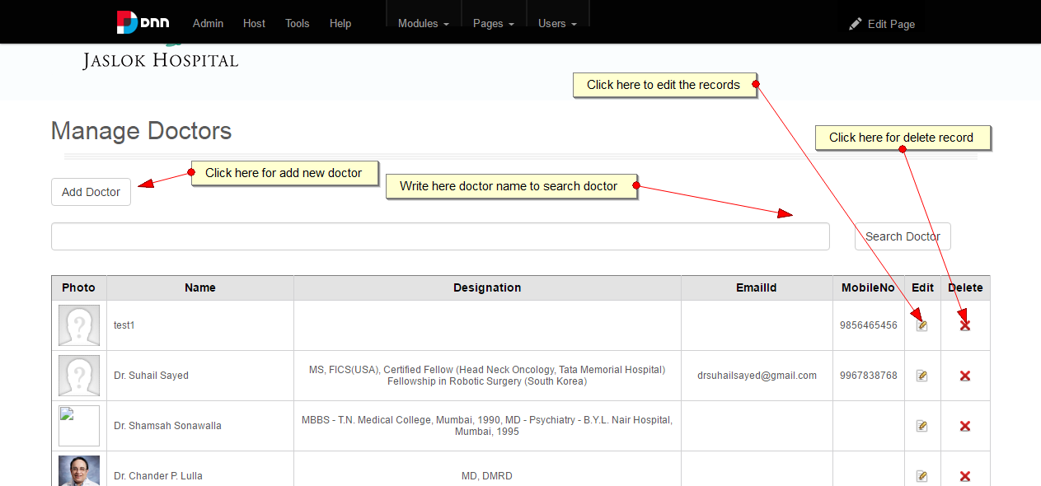

2.

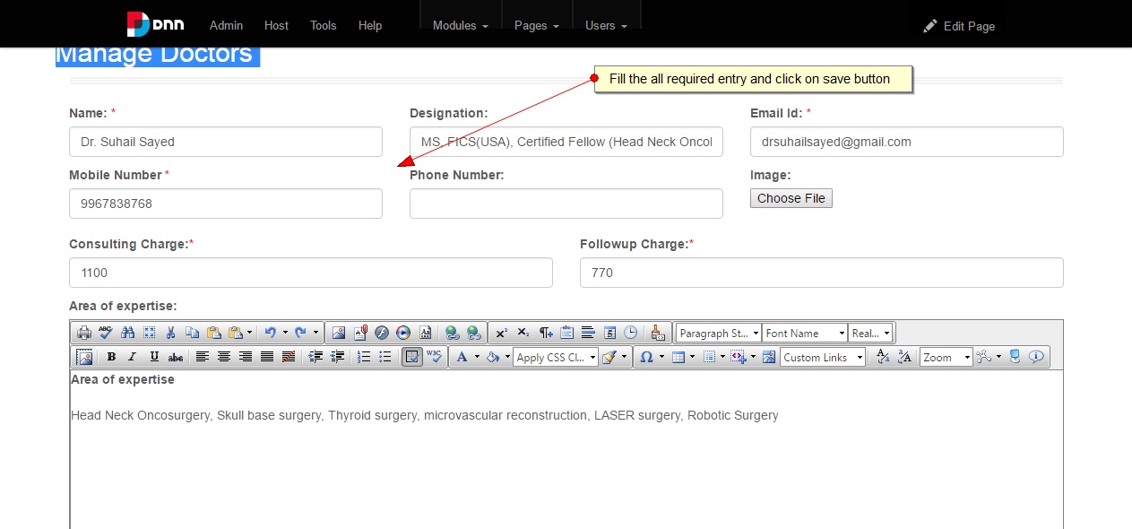

3.

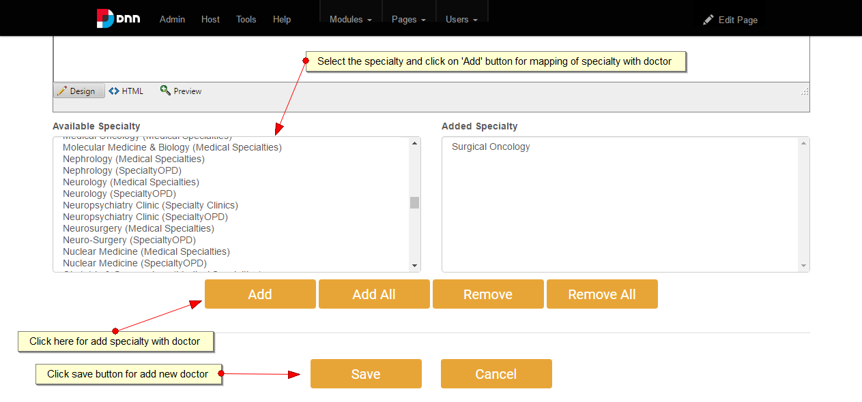

4.

